AIR UNIVERSITY, ISLAMABAD

**Question 01:**

**For the following IP Addresses, Identify the following:**

1. **Class (A, B, C, D, E)**
2. **Network-Host Division (Example: N.N.N.H)**
3. **Subnet Mask (Example: 255.0.0.0)**

|  |  |  |  |  |
| --- | --- | --- | --- | --- |
| NO. | **IP ADDRESSES** | **NETWORK**  **HOST DIVISION** | **SUBNET MASK** | **CLASSES** |
| 1 | **139.34.23.1** | **N.N.H.H** | **255.255.0.0** | **B** |
| 2 | **219.80.60.110** | **N.N.N.H** | **255.255.255.0** | **C** |
| 3 | **219.80.60.110** | **N.H.H.H** | **255.0.0.0** | **A** |
| 4 | **10.80.10.1** | **N.H.H.H** | **255.0.0.0** | **A** |
| 5 | **100.1.1.1** | **N.H.H.H** | **255.0.0.0** | **A** |
| 6 | **122.11.12.22** | **N.H.H.H** | **255.0.0.0** | **A** |
| 7 | **166.77.88.80** | **N.N.H.H** | **255.255.0.0** | **B** |
| 8 | **34.200.234.12** | **N.H.H.H** | **255.0.0.0** | **A** |
| 9 | **193.254.254.254** | **N.N.N.H** | **255.255.255.0** | **C** |
| 10 | **200.200.200.200** | **N.N.N.H** | **255.255.255.0** | **C** |

**Question 02:**

**Complete the following network in Packet Tracer:**

**Please take screenshots when all configurations are done and PING is successful.**

**Network-1:**

1. **Add a PC**
   1. **Assign IP address (last 2 digits of student ID for each octet)**
   2. **Example: ID = 201764, IP = 64.64.64.64**
   3. **If last 2 digits of your ID are 00, then assign 100.100.100.100**
2. **Add a Switch (2960)**
3. **Connect the PC to the Switch**
4. **Capture screenshot of the “IP configuration” of PC**

**Network-2:**

1. **Add a PC**

**a. Assign IP address of 200.200.200.200**

1. **Add a Switch (2960)**
2. **Connect the PC to the Switch**
3. **Capture screenshot of the “IP configuration” of PC**

**Add a Router (2911):**

1. **Connect both of the Switches to Router keeping in mind the respective Port (FastEthernet or GigabitEthernet)**
2. **Assign IPs to both of the Router Interfaces i.e. one for Network-1 and other for Network-2**
3. **Capture screenshots of Both of the Router Interfaces**

**PING:**

**1. Send PING request from Network-2 i.e. PC = 200.200.200.200 to the Network-1 i.e. PC = IP with your Student_ID last 2 digits Capture the screenshot of “PING Request”.**

PC1:

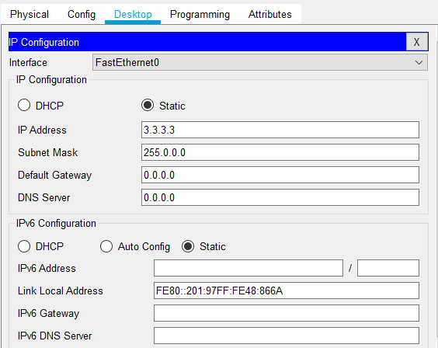

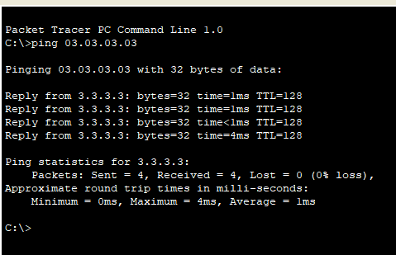

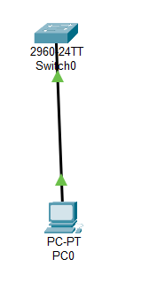

PC2:

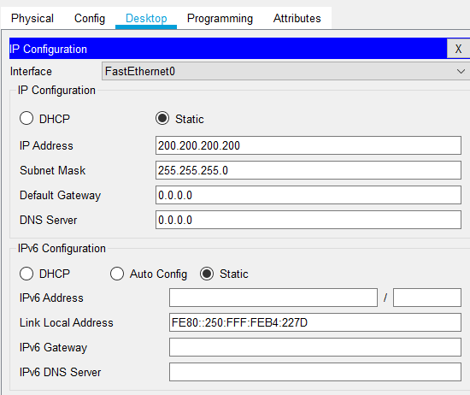

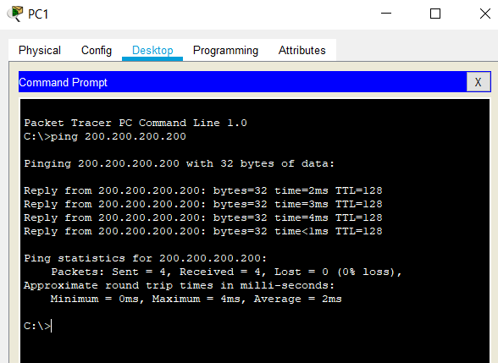

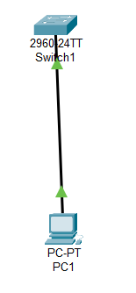

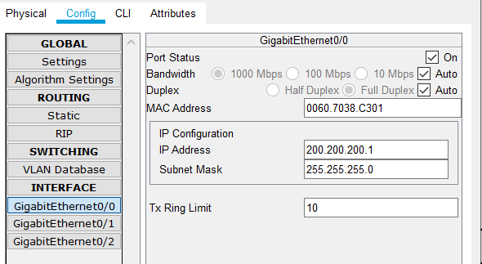

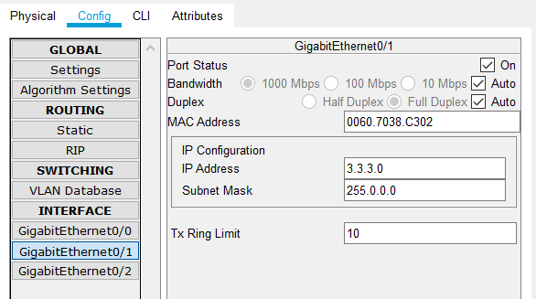

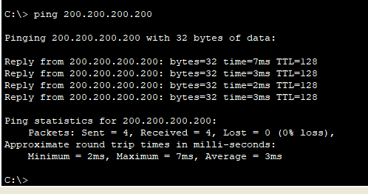

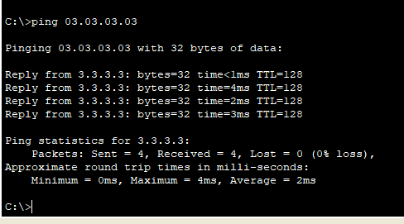

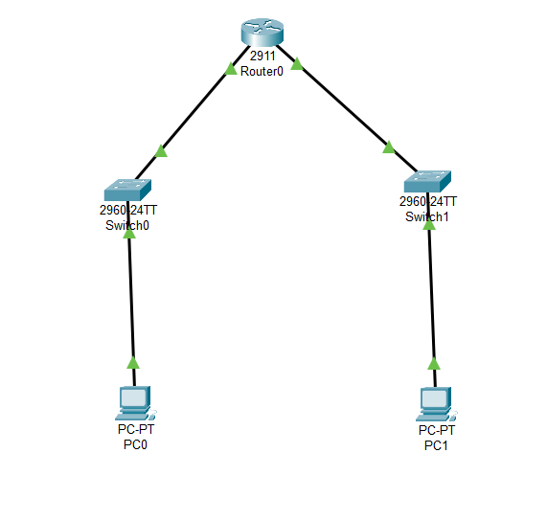

**Question 03:**

**Implement Static Routing in the Network**

**Network-1:**

1. **Add first PC**
   1. **Assign IP address (last 2 digits of student ID for each octet)**
   2. **Example: ID = 201764, IP = 64.64.64.64**
   3. **If last 2 digits of your ID are 00, then assign 100.100.100.100**
2. **Add second PC**
   1. **Assign the NEXT IP address**
   2. **Example: ID = 201764, IP-1 = 64.64.64.64, IP-2 = 64.64.64.65**
   3. **In case of 100.100.100.100, assign 101.101.101.101**
3. **Add a Switch (2960)**
4. **Connect both of the PCs to the Switch**
5. **Capture screenshot of the “IP configuration” of both of the PCs**
6. **Add a Router (2911): (Router-1)**
7. **Connect the switch to Router keeping in mind the respective Port (FastEthernet or**

**GigabitEthernet)**

1. **Assign IPs to both of the Router Interfaces i.e. one for Network-1 and other for**

**Router-2**

1. **Capture screenshots of Both of the Router Interfaces**

**Network-2:**

1. **Add first PC**
   1. **Assign IP address 192.192.192.192**
2. **Add second PC**
   1. **Assign IP address 192.192.192.193**
3. **Add a Switch (2960)**
4. **Connect both of the PCs to the Switch**
5. **Capture screenshot of the “IP configuration” of both of the PCs**
6. **Add a Router (2911): (Router-2)**
7. **Connect the switch to Router keeping in mind the respective Port (FastEthernet or**

**GigabitEthernet)**

1. **Assign IPs to both of the Router Interfaces i.e. one for Network-2 and other for**

**Router-1**

1. **Capture screenshots of Both of the Router Interfaces**

**Static Routing:**

1. **Implement Static Routing and configure both Routers**
2. **Establish communication between both networks i.e. Network-1 and Network-2**

**PING:**

1. **Generate a ping request from Network 2 to Network 1**
2. **Example: Ping from 192.192.192.192 to 64.64.64.64 (Or Your IP)**
3. **Take Screenshot of the PING request**

PC 0

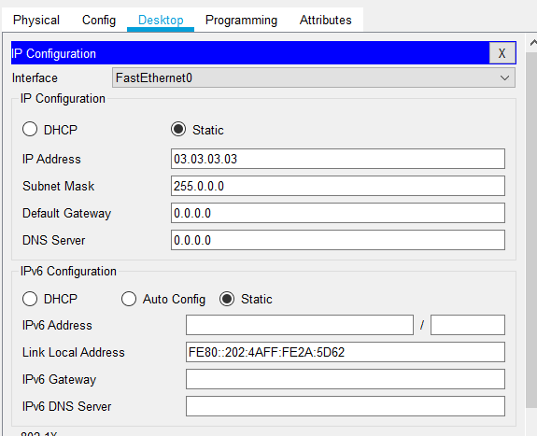

PC1

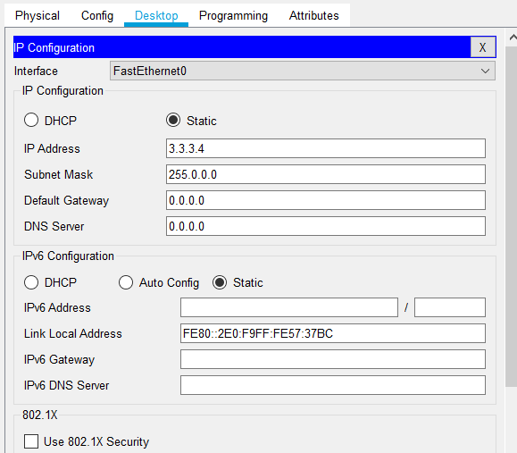

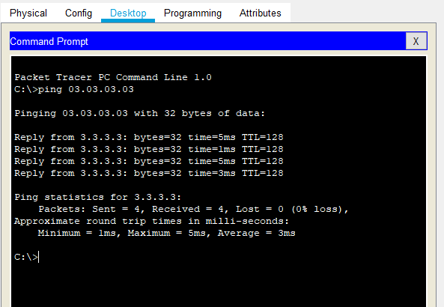

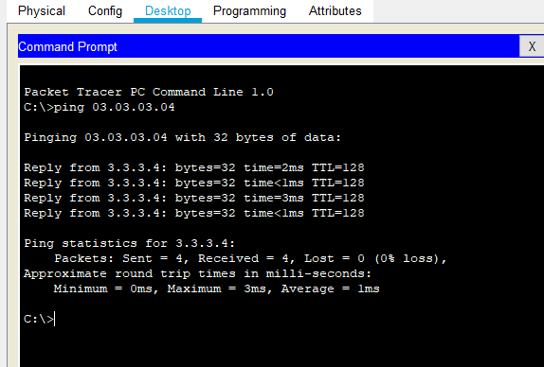

PC2:

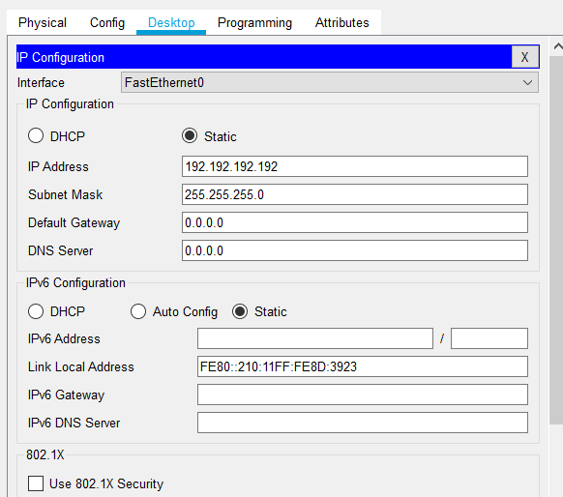

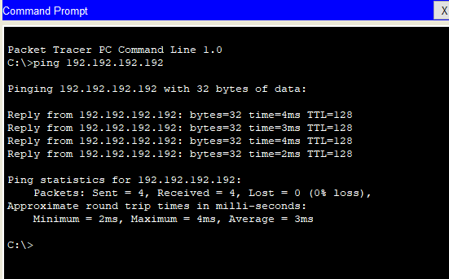

PC 3:

